GVT Experiment log

Date: Sept 2, 2015
Aircraft: Hati(mAEwing2 after cut cut)

Experiment Details
2
X
Y
Point locations
20
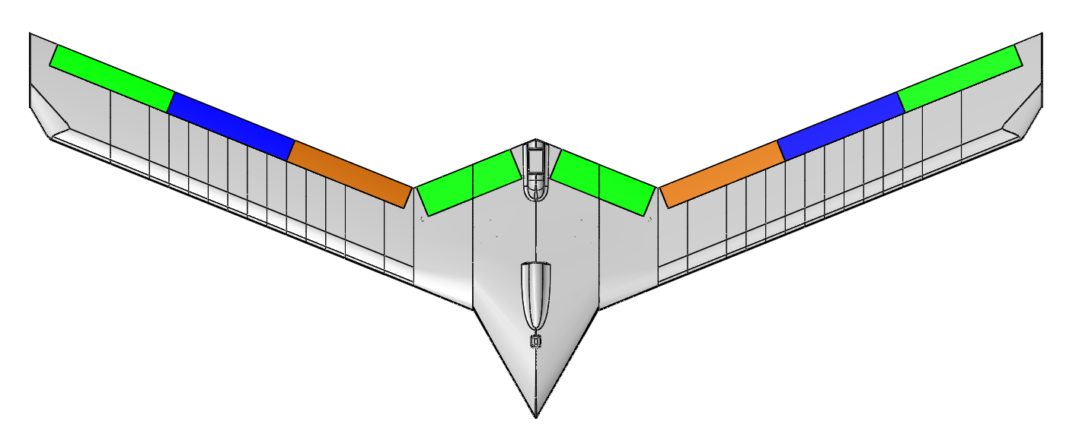
1
4
3
6
5
7
8
9
10
11
12
13
14
15
16
17
18
19
Point | X-Coordinate (in) | Y-Coordinate (in)
1 | 16.86 | 18.57
2 | 16.86 | 24.57
3 | 26.02 | 22.27
4 | 26.02 | 28.27
5 | 35.18 | 25.97
6 | 35.18 | 31.97
7 | 44.22 | 29.62
8 | 44.22 | 35.64
9 | 53.37 | 33.32
10 | 53.37 | 39.32
11 | -16.86 | 18.57
12 | -16.86 | 24.57
13 | -26.02 | 22.27
14 | -26.02 | 28.27
15 | -35.18 | 25.97
16 | -35.18 | 31.97
17 | -44.22 | 29.62
18 | -44.22 | 35.64
19 | -53.37 | 33.32
20 | -53.37 | 39.32

Run Details

Run # | Position: Accel 1 | Position: Accel 2
1 | 11 | 12
2 | 13 | 14
3 | 15 | 16
4 | 17 | 18
5 | 19 | 20
6 | 1 | 2
7 | 3 | 4
8 | 5 | 6
9 | 7 | 8
10 | 9 | 10

